User Guide

jWebSocket
SMS Gateway

Mayra Eva Marañón Rodriguez

1. Characteristics of the solution
The gateway allows sending SMS text messages to mobile phones (SMS) through the WebSocket protocol, which provides high speed and real-time work. The application is developed with the framework jWebSocket.
It is an SMS gateway can be used as media for standalone applications, and functionality that enriches applications or as a means to send SMS messages from a web page. It is a gateway that has captcha mechanism is a challenge-response test used to determine when the user is human or not. This functionality is used to prevent robots, also called spambots, can use the SMS service provided by the SMS gateway.
- Main functionalities
- SMS Gateway with validation method has anti-spam captcha mechanism is a challenge-response test used to determine when the user is human or not.
- Send SMS allows you to send composed message cell phone number id of the person who sends and message text.
- Send bulk SMS allows the sending of message consist of a list of phone numbers, go to the person who sends and message text.
- Send longer SMS allows the sending of message numbers cellular compounds, id of the individual sender and message text with 160 characters.
- Reception status of messages sent for obtaining a satisfactory response sent the message.

The SMS Gateway is an SMS service that offers the possibility of integration of any client software with the gateway for sending SMS messages in a simple and fast. In today's world where the search is defined interaction between the Web and mobile gateways are used in virtually all sectors of society. Sending SMS from the web is used in monitoring applications for reports fast in sending immediate data of bank statements, notices of sport, weather, news, horoscopes among many other applications that may use of this service.
3. Problems to be solved
Problem | Contributions of the solution
The framework jWebSocket presents problems in SMS communication service. | SMS Gateway is an application that allows communication between the Web using the WebSocket protocol with the mobile phone network. What provides the framework for a media jWebScoket SMS.

4. Glossary
SMS: Short Message Service.
Captcha: Automatic test for differentiating human and machine.

5. Model of the solution
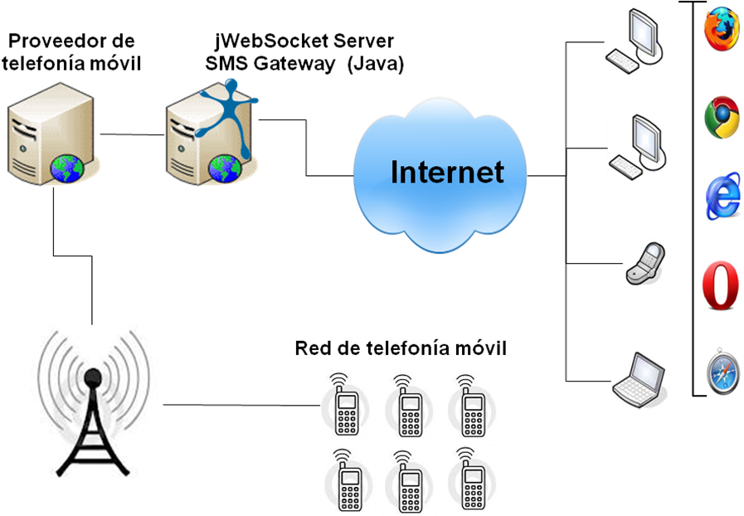
To access the SMS gateway application is only required the user to use a browser that supports WebSocket protocol. Then you must authenticate to the application to meet the challenge of captcha and send the SMS you want. The server jWebSocket which is installed on your PC communicates with the mobile phone provider which sends SMS to the mobile phone network.

7. Requirements for Use
To use the SMS gateway must have Internet access and use any of the browsers that support the communication protocol WebSocket. Some of them are Google Chrome 4, Safari 5, Mozilla Firefox 8, Opera 11 and Internet Explorer 10.

8. Roles of the solution
System User: Interact with the application to meet the challenge of captcha and send the SMS you want.

9. System Operation
Initial view and main application: Allows users with permission can authenticate application so you can interact with the application to meet the challenge of captcha and send the SMS you want.
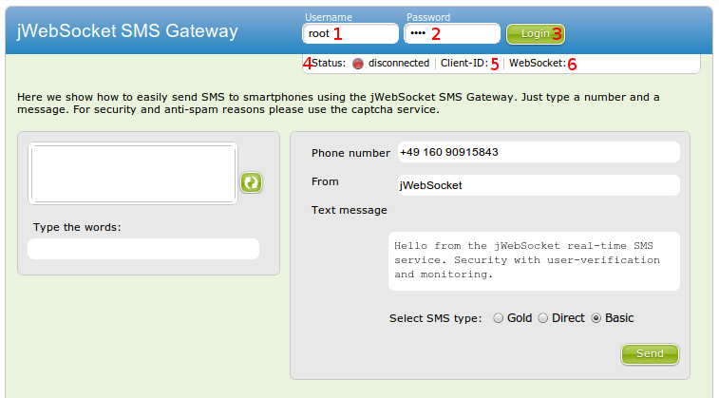

1-> Field to insert the user to authenticate to the application.
2-> Field to insert the password.
3-> To access the application.
4-> Displays the status of the application (Authenticated / Offline).
5-> Displays the id of the logged in user.
6-> Displays the protocol information.

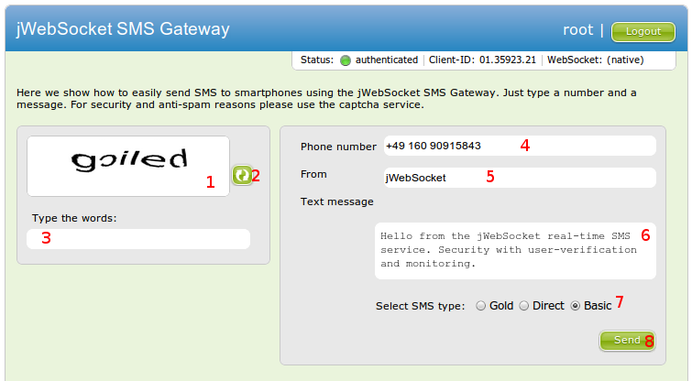

1-> Image with challenge-response captcha image.
2-> Button to generate a challenge-response of different captcha image.
3-> Field for the key word of challenge-response captcha image.
4-> Field to enter the number or list of numbers to which the user wants to send the SMS.
5-> Input field for the id of the user sending the SMS.
6-> Input field for the SMS message text.
7-> Select type of SMS sent.
8-> Button that allows the verification of the keyword and also sending the SMS.

9. Configurations of the solution
This application is not required configurations and customizations.

10. Rules of the solution
R1: If the user mistype your username or password, during access to the application, the system issues an error message and does not continue with the normal flow. Solution: The user must repeat your username and password again.
R2: If the user mistype the keyword of the challenge-response captcha image the system issues an error message and does not continue with the normal flow. Solution: The user must repeat again the challenge-response captcha image and then correspondingly this will send the SMS message.

